Satellite-Based Monitoring Reveals Key Drivers of Wind Turbine Wake Losses
Overview of WP1 and WP2
Researcher Cem Özcan
Overview
As part of the InnoWind project, a new satellite-based method has been developed to monitor and measure wind turbine wake effects in offshore wind farms. These wakes—areas of reduced wind speed behind turbines—are a well-known source of energy loss, potentially reducing total wind farm production by 10–20%. For operators, this can mean millions of euros in lost annual revenue.
The research demonstrates that satellite radar data can be used as a reliable and scalable tool to detect these wake effects and quantify their impact on wind farm performance.

How the Method Works
The approach uses radar data from the European Space Agency’s Sentinel-1 satellites. These satellites orbit Earth at around 700 km altitude and can observe the ocean surface in all weather conditions, day and night.
Wind creates small waves that roughen the sea surface. When wind slows down—such as behind a turbine—the surface becomes smoother. The satellite detects these changes in surface roughness, allowing wind speed to be calculated.
By processing these radar signals, the project produces detailed maps of wind speed and clearly identifies wake patterns behind turbines.

Study Area: Tahkoluoto Offshore Wind Farm
The method was tested at the Tahkoluoto offshore wind farm near Pori, Finland. This site includes 11 turbines with a total capacity of approximately 44 MW and is located in the Gulf of Bothnia.
Tahkoluoto provides an ideal test environment due to its northern location, ice-resistant turbine design, and the availability of nearby weather measurements. These conditions make it well suited for validating new monitoring techniques before applying them to larger wind farms.

Data and Analysis Achievements
Since summer 2025, significant progress has been made in building a robust analysis framework:
1. Fully Developed Processing Pipeline
A complete data processing chain has been established, covering:
- Raw satellite data acquisition
- Wind speed retrieval
- Wake detection and quantification
This pipeline can process large datasets spanning multiple years and can be adapted for use at other wind farms.
2. Long-Term Satellite Dataset
A dataset covering 7.5 years (2017–2024) was assembled. During this period:
- Over 1,500 satellite passes were recorded
- 72 high-quality observations were selected for detailed analysis
The filtering process ensured that only reliable data were used. Observations affected by ice, unsuitable viewing angles, or missing weather data were excluded. The selected subset also focused on specific wind directions to ensure consistent and accurate analysis.

Key Scientific Findings
The most important outcome of the research is the clear link between weather conditions and wake behavior. Weather conditions strongly influence wake effects.
The study shows that atmospheric stability plays a critical role in determining wake strength:
- Stable conditions (calm weather, common in the Baltic Sea)
- Long, clearly defined wakes
- Wind speed reduction of 12–14%

- Neutral conditions
- Moderate wake effects
- Wind speed reduction of 3–6%

- Unstable conditions (turbulent weather)
- Wakes dissipate quickly
- Minimal impact on wind speed

Impact on Energy Production
These differences are highly important for energy output. Wind power depends on the cube of wind speed, meaning even small reductions have large effects.
For example: A 12% drop in wind speed can result in approximately a 30% decrease in power production for turbines located in the wake. This shows that under stable weather conditions—frequent in the Gulf of Bothnia—wake losses can significantly reduce the performance of a wind farm.

Validation and Reliability of Results
The findings are consistent with established scientific theory, strengthening confidence in the results. Importantly, this study benefits from high-quality local weather measurements: a nearby buoy and weather station operated by the Finnish Meteorological Institute (FMI) provided independent data.
These measurements allowed accurate classification of atmospheric conditions during satellite observations. Further validation will be conducted once operational turbine data (SCADA data) becomes available. This will enable direct comparison between observed wake effects and actual energy production.
Indicators for the InnoWind Project
The work provides several key indicators of success for the project:
✅ Demonstration of a working satellite-based wake monitoring method
✅ Creation of a long-term, quality-controlled dataset
✅ Development of a scalable and transferable analysis pipeline

Conclusion
This research demonstrates that satellite radar data can provide a practical and powerful tool for understanding wind turbine wake effects. The findings highlight that weather conditions—especially atmospheric stability—play a critical role in determining wake strength and associated energy losses.
By enabling regular, large-scale monitoring of wakes, this approach offers a new way for wind farm operators to improve efficiency and reduce losses, supporting more cost-effective renewable energy production.

KUVAT:
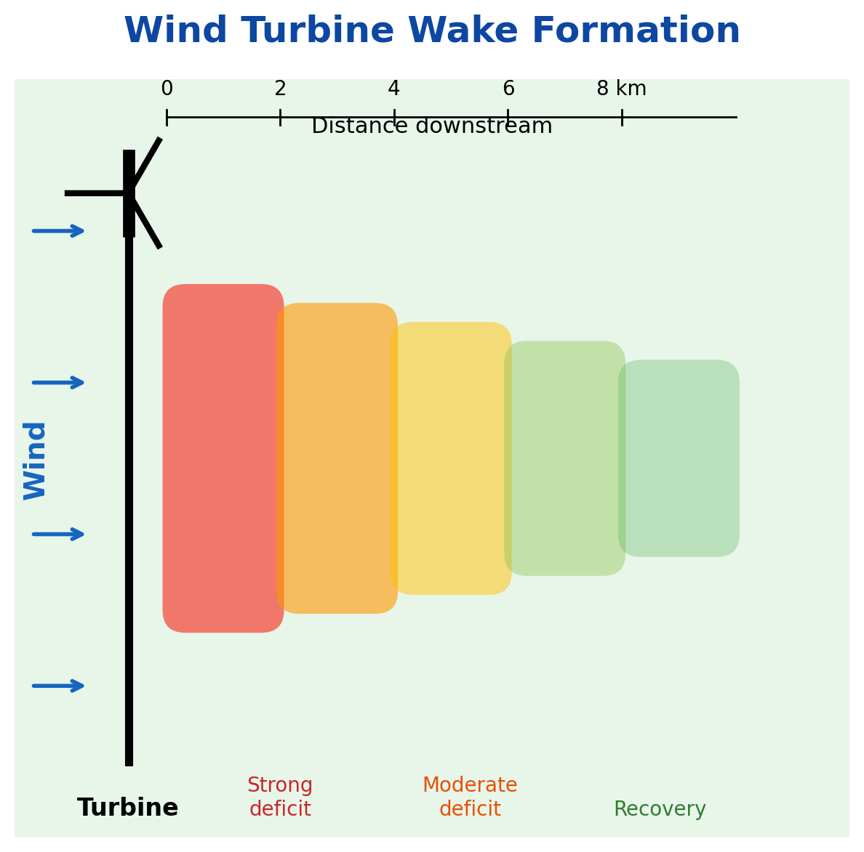
Wind turbine wakes are zones of reduced wind speed that form behind operating turbines and can extend several kilometers downstream. Schematic illustration of a wind turbine wake. Wind speed is reduced immediately behind the turbine (red) and gradually recovers with distance (green).

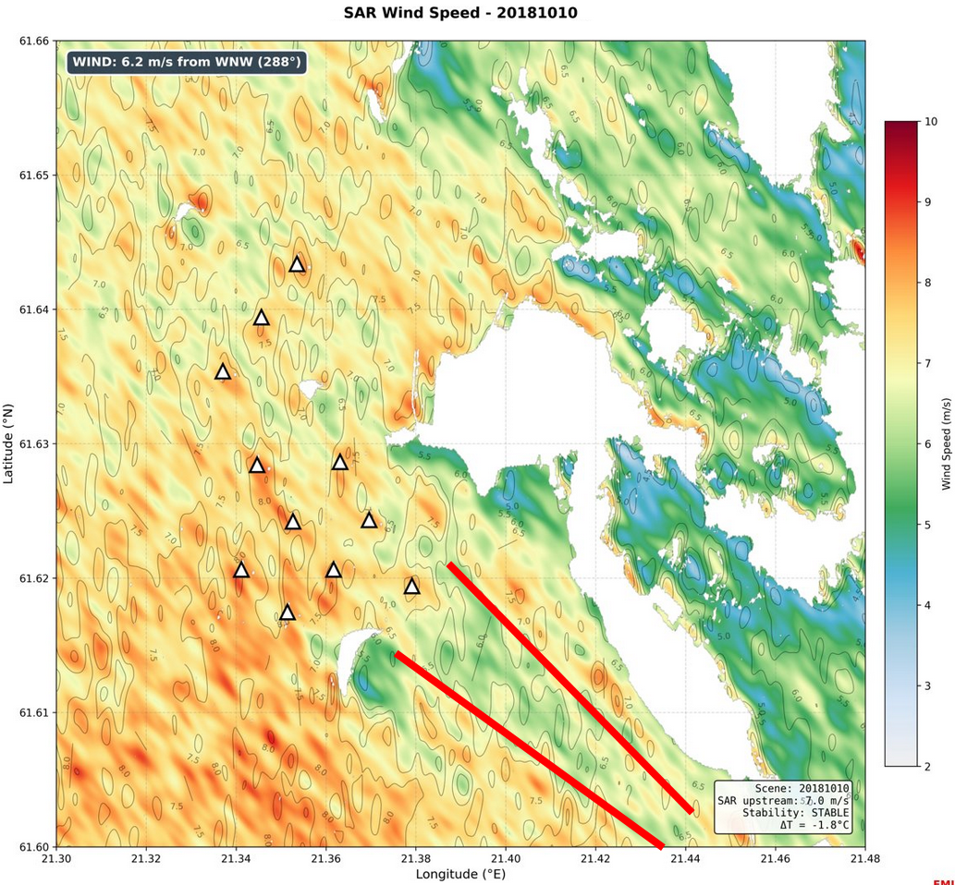
SAR Wind Speed Map
Close up satellite derived wind speed map over Tahkoluoto. Red/yellow indicates normal wind speeds (6–8 m/s). Green/blue streaks behind turbines show wake-induced wind speed reduction detected from a 700 km orbit altitude.

